

DPR DA281 til Rambøll Care

Brugervejledning i udtræk af opdateringsdata

DA281 version 1.0.6

Introduction
This guide is used for setup of DPR Updating, DA205, DA281 and use of the formation of files of extracts data from DPR for use in an external program.
Customizing the DPR Update (DA205)
Extract Program DA281 exercising some control tables to be updated by the DPR Updating Program DA205.EXE.
In order to use the DA281 is an assumption that the municipality / county have installed version 4.4.0 or higher of program DA205.
Must specify a parameter to the program DA205, which tells that the program must maintain control tables for use by DPR extraction programs. Dialog box for DA205 obtained by running the program DA205 with an "o" parameter. This can be done by example from a DOS prompt to write "DA205-o". See Figure 1

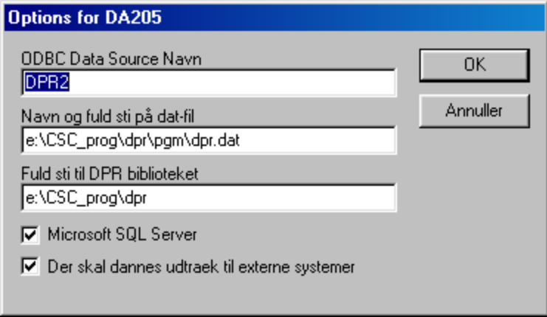
Figure 1 Configuring DA205 using the DA281.

It is important to have "notches" in the field "should be formed extraction for external systems.
In Figure 2 shows an example of a log from program DA205, which provides updated information on the table DTPERSAJOUR. DA281 uses table DTPERSAJOUR to manage the updates of the external program.
It is important that the municipality / county has established management tables DTPERSAJOUR and DTPERSAJOURHIST the DPR database.

-------------------------------------------------- -----------------------------
>>> DECENTRALIZED Population <<< 07/06 2000 kl. 165407
Version of the DA205: 4.4.0
-------------------------------------------------- -----------------------------

UPDATE OF DECENTRALIZED Population ARE MADE ON: 07/06 2000

DPR has been updated TRANSACTIONS WITH FORMED IN THE CPR: 06/06 2000

NUMBER OF TRANSACTIONS FOR Updates are: PERSONS: Authority / POST:
SUPPLIED: 1019 0
USED: 1019 0
----------- -----------
DIFFERENCE: 0 0
=========== ===========

-------------------------------------------------- -----------------------------

*** Status updated in Table DTPERSAJOUR:
Number of inserts = 97
Number of updates = 3
Number of same = 919

Figure 2 Example of log file from DA205.

Configuring DA281
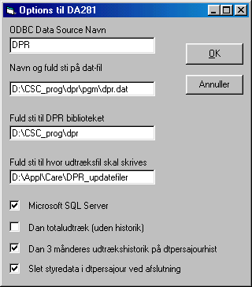
In the dialog box to program DA281 may be different parameters that govern conduct of the program. Dialog box appears first program DA281 run together when you press the button 'Options ...' from the start window.

Figure 3 Dialog to DA281.

The following provides guidance on completing the dialog box. Parameter data is stored in Registry Editor, as shown in the window in Figure 4

ODBC Data Source Name
Enter the symbolic name of the 32-bit data source, which the program must apply. Normally used the same data source as the other DPR programs.
DA281 Program to run on the same server and be located in the same location as the other DPR server applications.
Name and full path of data file
Enter the path to the dpr.dat file that the other DPR server applications using.
Full path to DPR library
Here set the path to where DPR library is installed on the NT server.
Full path to where udtræksfil be written
Here, type the fully qualified path to the file drawer through.
The files are named as follows: "Dyymmdd. DPRudtrk1 " where yymmdd is the current DPR update date.
Checkbox - "Microsoft SQL Server"
Should normally only be filled with "click" when the MS SQL Server is used as the database software.
Checkbox - "Dan total extracts (without history)"
If desired extract as a daily total extraction, rather than just to receive the daily changes made to "tick" in this field. Supplied as data for all persons on the Table DTTOTAL.
Checkbox - "Dan 3-month history of extraction DTPERSAJOURHIST"
History table for the daily update files. It saves information about PRN, DPRAJDTO and LEVAJDTO. The history is saved on the last 3 months of supplies. Can be handy to have available for follow-up.
Checkbox - "Delete track data DTPERSAJOUR at the end"
Should normally be filled with "notches". If the municipality has a different extraction program that makes use of control tables must be coordinated, which extracts program to delete the track table DTPERSAJOUR.

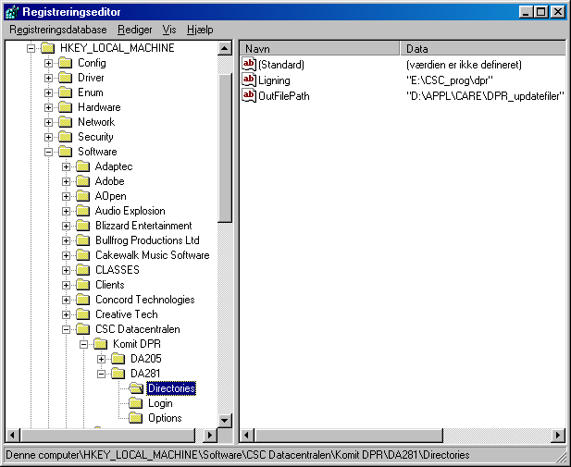
Figure 4 DA281 parameter data stored in the registry.

Proceedings of DA281 ¤
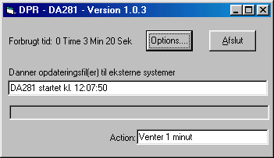When DA281 runs in interactive mode from the following window. It is possible to change the options for the program within the first minutes by pressing the button 'Options ..'.

Figure 5 DA281 window during interactive settlement.

By pressing the 'Exit' displays the following dialog and the possibility to stop the program.

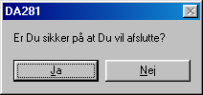
Figure 6 Dialog box for closing the DA281.

Logfile
Program DA281 forms accumulated logs each month, in which it is possible to follow up the operation. For example formed Logfile of June 2000 on location:
E: \ CSC_prog \ DPR \ Logs \ 281_0006.log

***
*** Example of log: log 281_0006
***

*** DA281 started on 12.06.2000 kl. 16:17:15
DPR update date: 20000605 last update delivered DPR date: 0
On the file D: \ Appl \ Care \ DPR_updatefiler \ D000605.DPRudtrk1 are printed 33,279 data records
=== DA281 joined on 12.06.2000 kl. 16:43:34, drawer type = TOTAL Extract

*** DA281 started on 12.06.2000 kl. 17:23:33
DPR update date: 20000606 last update delivered DPR date: 20000605
On the file D: \ Appl \ Care \ DPR_updatefiler \ D000606.DPRudtrk1 are printed 97 data records
=== DA281 joined on 12.06.2000 kl. 17:23:40, drawer type = OPDATERINGSUDTR

*** DA281 started on 12.06.2000 kl. 17:34:52
DPR update date: 20000607 last update delivered DPR date: 20000606
On the file D: \ Appl \ Care \ DPR_updatefiler \ D000607.DPRudtrk1 are printed 108 data records
=== DA281 joined on 12.06.2000 kl. 17:34:59, drawer type = OPDATERINGSUDTR

Figure 7 Example of log file from DA281.

Placing outputfile
By liquidation of DA281 ranked output as shown in the figure below.
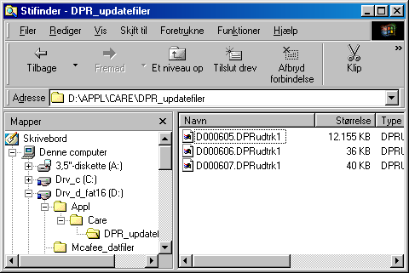
Figure 8 Example of location of the outputfile from DA281 to Rambøll Care.

Data structure for program DA281 to Rambøll Care - version 1.0.6

